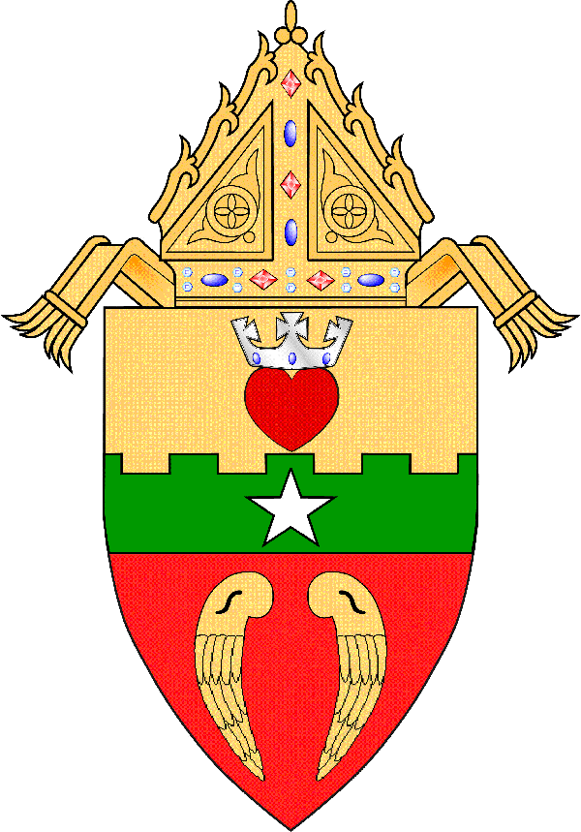DIOCESE OF SAN ANGELO

Diocesan Fall Priests’ Convocation

*October 7-8, 2025*

September 15, 2025

Dear Brother Priests,

The **Diocesan Fall Priests’ Convocation** will be held at Christ the King Retreat Center on October 7-8, 2025.

I invite you to join us for this year’s Fall Convocation titled “Living with Hope: Dealing with Reality, Expectations and Disappointments.” How do we maintain hope in an imperfect world, an imperfect Church, an imperfect self? Our presenter will be Bishop Michael J. Sis.

Bishop Sis grew up in Bryan. He is the son of Raymond and Janice Sis. Born on January 9, 1960, he is the fourth of five children. He attended St. Joseph Catholic School and Bryan Public Schools in Bryan. He graduated from Bryan High School in 1978. He earned an undergraduate degree in Philosophy in 1982 from the University of Notre Dame in South Bend, Ind., where he attended Moreau Seminary.

Bishop Sis studied Theology at the North American College in Rome, receiving degrees from the Pontifical Gregorian University in 1985 and the Alphonsian Academy of the Pontifical Lateran University in 1990. He was ordained a priest for the Diocese of Austin on July 19, 1986. He became Bishop of the Diocese of San Angelo on January 27, 2014.

The Tuesday dinner will honor our Jubilarians.

I look forward to seeing you all at this event.

Sincerely yours in Christ,

Msgr. Larry J. Droll

Vicar for Priests

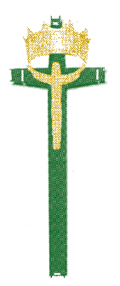

Christ the King Retreat Center

802 Ford Street, San Angelo, TX 76905

Greetings:

We are excited to announce that it is time to register for the Diocesan Fall priests’ convocation to be held at Christ the King Retreat Center.

This year’s fall priests’ convocation is scheduled for October 7-8, 2025. The program will begin with lunch on Tuesday, October 7th and will conclude with lunch on Wednesday, October 8th.

You should find the registration form and agenda attached to this email. Registration and payment can also be made using the Diocese of San Angelo Website, click on the Retreat Center link, and then on the Diocesan Fall Priests’ Conference Registration form.

Please be sure to send in your registration form and payment to Christ the King Retreat Center by October 1, 2025, so that all preparations can be made in anticipation of your arrival. As always, we will be happy to assist you with your registration over the phone or email.

Thank you we look forward to seeing you all again.

Grace and Blessings,

Jo Ann R. Martinez

Jo Ann R. Martinez

Guest Services Coordinator

Christ the King Retreat Center

[jmartinez@sanangelodiocese.org](mailto:jmartinez@sanangelodiocese.org)

* To concelebrate, bring alb & green stole.
* Please be sure and use the registration form to let us know that you are coming. & Remember to indicate whether or not you will be joining us for lunch on Tuesday and also on Wednesday.
* Please let us know if you will be attending the Jubilarian Banquet on Tuesday, October 7th.

Diocese of San Angelo

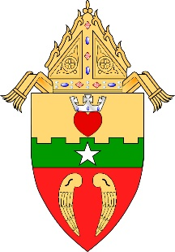Fall Priests Convocation

October 7-8, 2025

“Living with Hope”

“Dealing with Reality, Expectations & Disappointment.”

“How one lives as we encounter living in an imperfect World, Church & Self”.

Presented by Bishop Michael J. Sis

Registration & Conference Fees

Please be sure to register by Wednesday, October 1, 2025

Name:

Parish:

City:

Contact #:

Email:

FEES

$174 Overnight Room Accommodations $122 Non-Overnight Accommodations

Payment Enclosed  I will bring Payment with me  Please bill my Parish  Bill DOSA  Retired Priest/Bill DOSA

Ground Floor Room Accommodations Requested (1st come 1st Served)  Handicap Room Accommodations Requested (1st come 1st Served)

Yes, I will arrive for lunch on Tuesday, October 7, 2025

Yes, I will stay for lunch on Wednesday, October 8, 2025

Yes, I will attend the Jubilarian Banquet on Tuesday, October 7, 2025

Please list any food allergies that we need to be aware of:



Diocese of San Angelo

Fall Priests Convocation

October 7-8, 2025

“Living with Hope”

Dealing with Reality, Expectations & Disappointment

How one lives as we encounter living in an imperfect World, Church, and Self

Presented by Bishop Michael J. Sis

Itinerary

Tuesday, October 7, 2025

12:30 pm Lunch

1:30 pm First Session:

Break

3:30 pm Second Session

Break

5:00 pm Evening Prayer

5:30 pm Wine & Cheese Social

6:00 pm Jubilarian Banquet at Christ the King Retreat Center

7:00 pm Conversations with the Presenter

Wednesday, October 8, 2025

8:00 am Morning Prayer and Mass with Bishop Sis

8:45 am Breakfast

9:30 am Third Session

Break

11:00 am Notes on Priestly Life with Bishop Sis

12:00 pm Lunch